*Florida International University*

*School of Computing and Information Sciences*

Software Engineering Focus

Feature Document

User Story ID #176

Create routes and components using angularJs

**Name:** Mariana Sebastian

**Team Member(s):** Nathally Perez

**Project:** Driverless Car Website 1.0

**Product Owner(s)**: Kianoosh Gholami

**Mentor(s)**: Mohsen Taheri

**Instructor**: Masoud Sadjadi

**User Story Name:**Create routes and components using angularJs

* Description: **As a** developer **I would like** to create routes and components for the front-end using AngularJS **so that** my web page will be more responsive and faster.

Acceptance Criteria

* Web page should have different components
* Web page should redirect to appropriate routes.

**Use Case #176**

* Name:Create routes and components using AngularJs
* Actor:Site visitor
* Preconditions: Connected to http://localhost:3000
* Description <Flow of events>:

1. Users can find navbar at the top of the page containing Home, products, technology, blog, about us, and contact us menu items.
2. When user clicks the menu items in the navbar it will redirect to the appropriate page.
3. Users can scroll down to find out more information about driverless car company.
4. User can find the footer with copyright information at the bottom of the website.

**Use Case Diagram:**

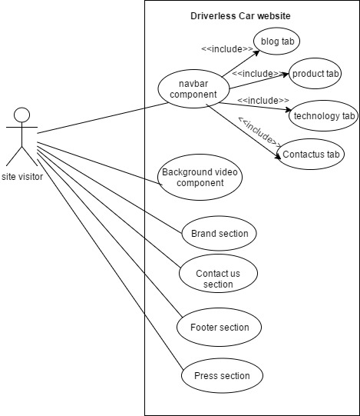

**Sequence Diagram**

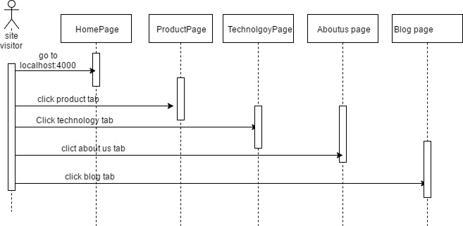

**Class Diagram**

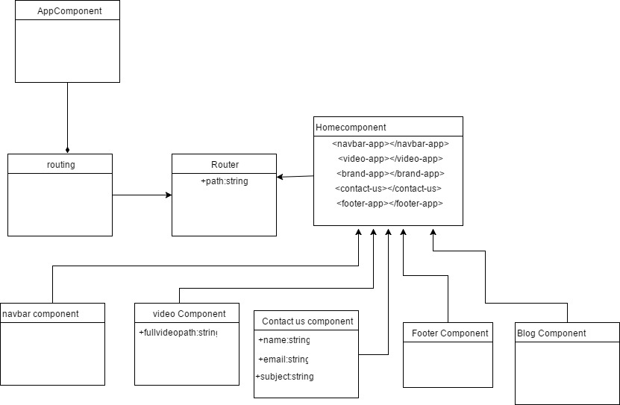

**Unit Test**

**Test case 1(Sunny Day)**

* Test case ID:Contactus_001
* Description/Summary of Test: Ensure the contact us tab navigate to the contact us form.
* Precondition:1. The server is running on the localhost port 3000.

2.User click contact us tab.

* Expected Results: User is redirected to the contact us form
* Actual Result: User is redirected to the contact us form
* Status (Fail/Pass): PASSED

**Test case 2(Sunny Day)**

* Test case ID:Tabs_002
* Description/Summary of Test: To test if the user can navigate back to the home page after visiting the different tab.
* Precondition:1. The server is running on the localhost port 3000.

2.User click product tab or technology tab or contact us tab or aboutus tab.

3. User click home tab

* Expected Results: User is redirected to the home page
* Actual Result: User is redirected to the home page
* Status (Fail/Pass): PASSED

**Test case 1(Rainy Day)**

* Test case ID:Contactus_001
* Description/Summary of Test:To test that the contact us tab won’t navigate to the contact us form if the internet connection is lost.
* Precondition:1. The server is running on the localhost port 3000.

2.User click contact us tab.

* Expected Results: User won’t be redirected to the contact us form
* Actual Result: User won’t be redirected to the contact us form
* Status (Fail/Pass): PASSED

**Visual User Guide** <like one or two screenshots of the feature. For the hardware project, a photo of device is required>

